F-53 -

Functionality
This functions allows you to post a vendor payment manually and clear the open item(s). Most of the outstanding invoices will be paid by payment program (F110), but it may happen that for some rarely used bank accounts this program will not be configured. In such cases payment for vendor documents will be done manually and you’ll need to post the bank documents using the transaction F-53.

Scenario
You need to pay an invoice based on a business requirement where you don’t want to wait for the next payment run or you need to pay an invoice from the bank account that is not relevant for the automatic payment program.

Requirements
Outstanding vendor invoice.

Menu Path | Accounting → Financial Accounting → Accounts Payable → Document entry → Outgoing payment → F-53 - Post
Transaction Code | F-53

1. Double click on F-53 – Post.
Post Outgoing Payments: Header Data

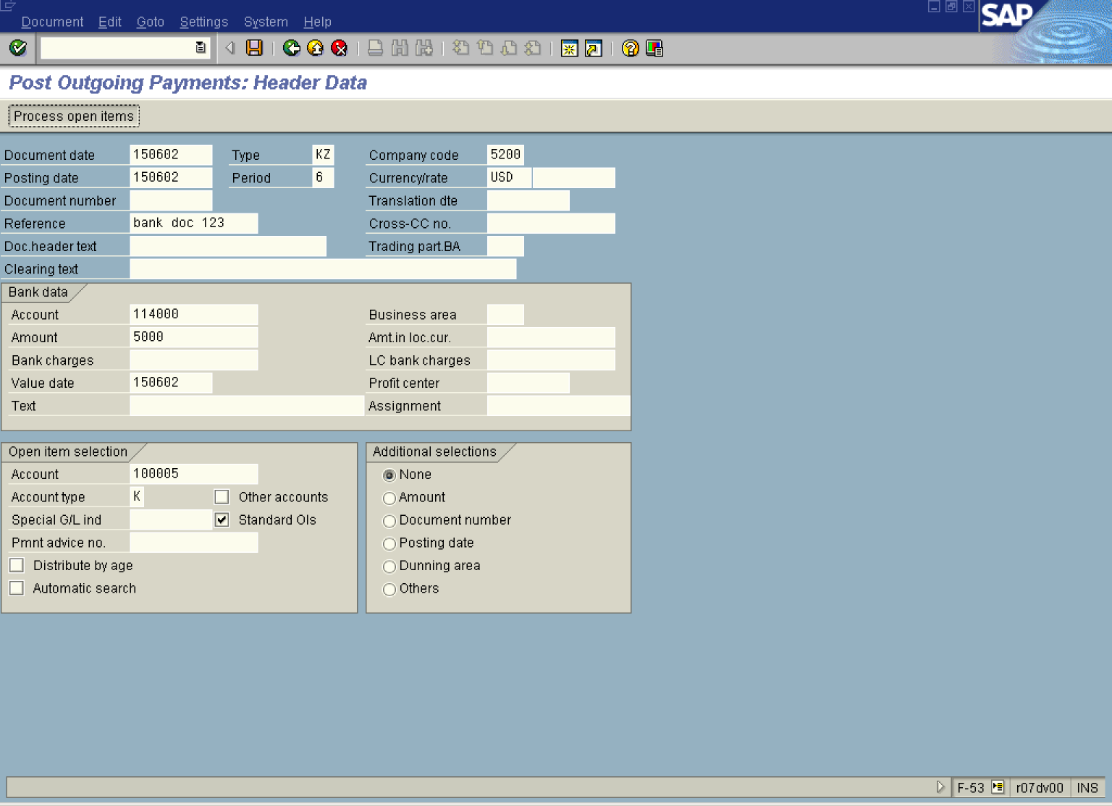

2. Update the following fields:

Field Name | Field Description | Values
Document date | Date the transaction occurred | Example: 150602
Company code | Code identifying a separate legal entity for which a separate set of accounts is maintained for external reporting purposes | Example: 5200
Posting date | Date that the business transaction occurred | Example: 150602
Currency/rate | Code identifying the currency used in the transaction | Example: USD
Reference | Vendor document reference, like invoice number | Example: 123
Account | Code identifying the General Ledger account | Example: 114000
Amount | Amount of a payment | Example: 5000
Value date | Today's date | Example: 150602
Account | Code identifying the Vendor account | Example: 100005

3. You entered the basic payment data. Now you need to clear your bank document with an outstanding invoice. To do so, click Process open items Button . The system will display full list of outstanding vendor documents:

Post Outgoing Payments: Process open items

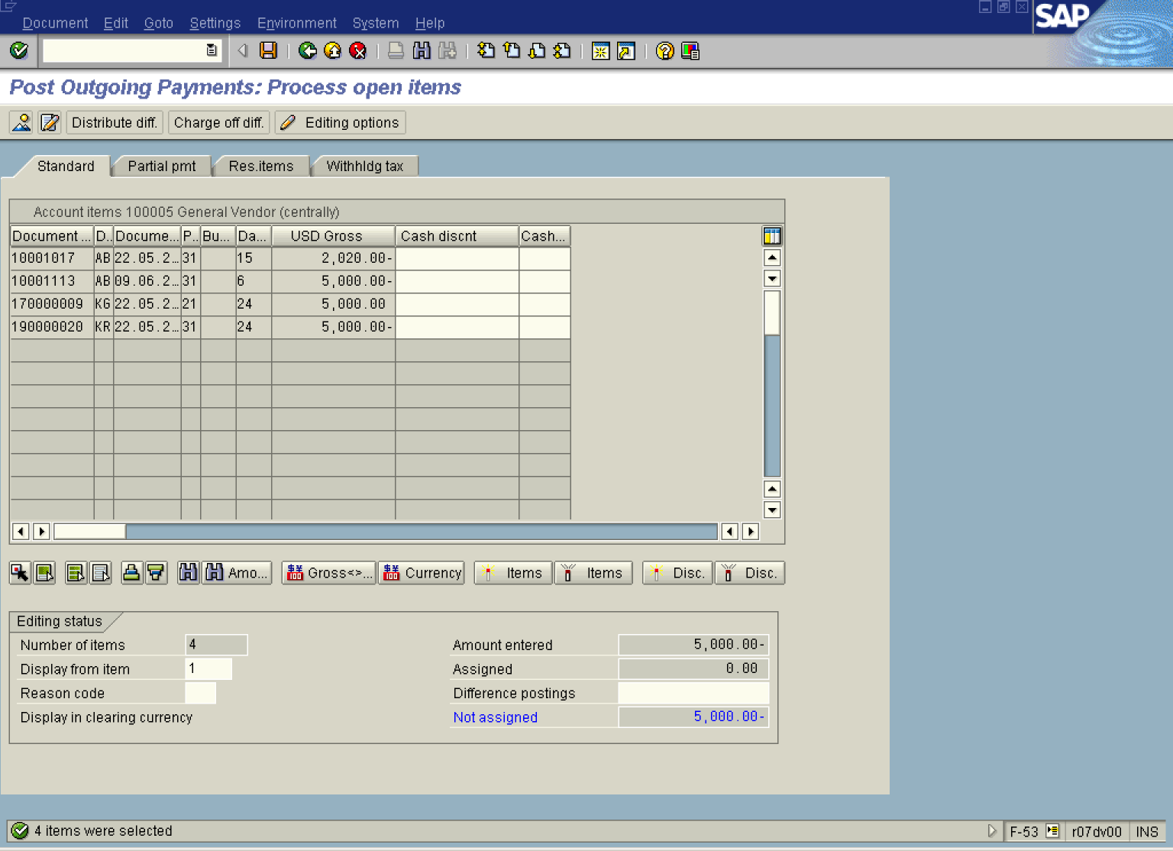

4. All invoices are not selected for processing. Select the document you want to clear with you payment by double-clicking on it (choose document 10001113). Now the selected document is displayed in blue and the value of the field “not assigned” is equal 0.

Post Outgoing Payments: Process open items

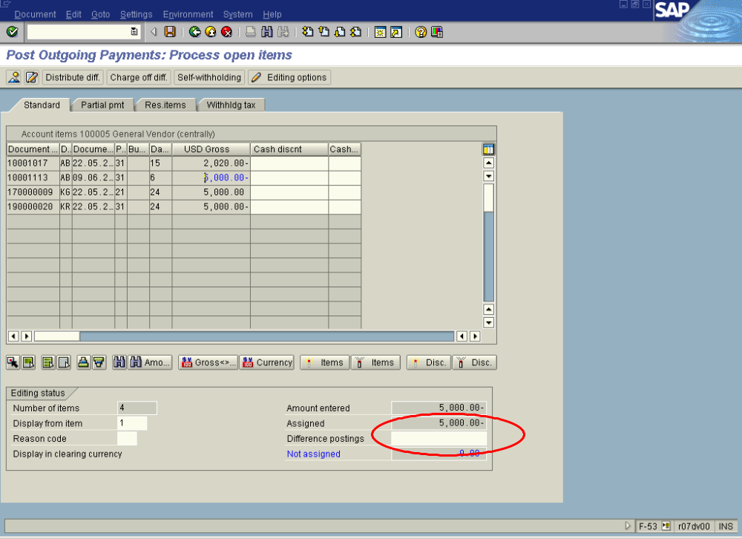
5. You can simulate your document before posting it. From the menu path choose “Document -> Simulate” to display document overview:

Post Outgoing Payments: Display Overview

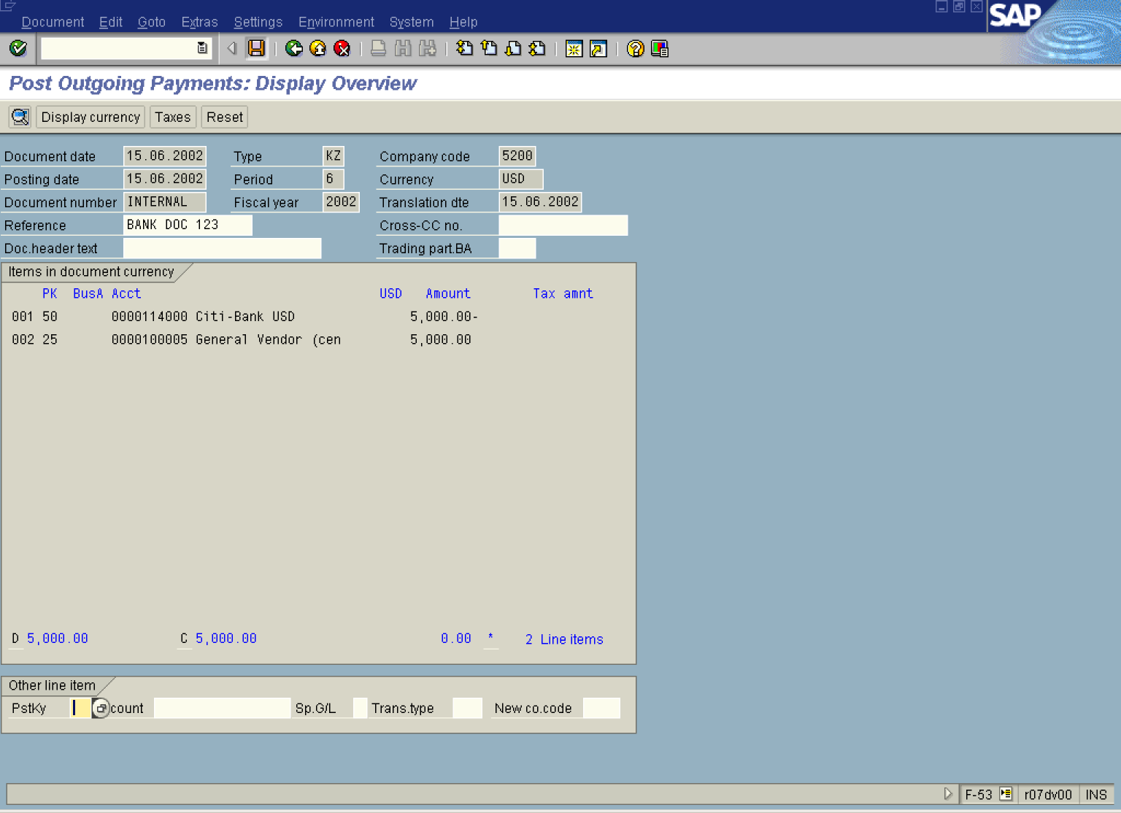

6. To post your document, click Save Button..
7. The message bar displays “The document number XXXXXXXX was created in company code 5200”.

